**Virtual Mouse Implementation using Open CV**

**Gubbala Durga Prasanth**

PG Scholar,Dept of CS , SVKP & Dr K S Raju Arts & Science College, Penugonda, A.P, India, g.prasanth1000@gmail.com

**P. Srinivasa Reddy**

Associate Professor, Dept of CS, SVKP & Dr K S Raju Arts & Science College, Penugonda, A.P, India. . psreddy1036@gmail.com

**Abstract**

Hand Gesture Recognition plays a key role in human-computer interactions. As we can see that there are so many new Technological advancements happening such as biometric authentication which we can see frequently in our smart phones, similarly hand gesture recognition is a modern way of human-computer interaction i.e., we can control our system by showing our hands in front of webcam and hand gesture recognition can be useful for all kinds of people. Based upon this idea this paper is presented. This paper provides a detailed explanation to the algorithms and methodologies for the color detection and virtual mouse.

**1. INTRODUCTION**

A Computer Mouse is an input device that helps to point and to interact with whatever that is being pointed. There are so many types of mouse in the current trend, there’s the mechanical mouse that consists of a single rubber ball which can rotate in any direction and the movement of the pointer is determined by the motion of that rubber ball. Later the mechanical mouse is replaced by the Optical Mouse. Optical Mouse consists of a led sensor to detect the movement of the pointer. Years Later the laser mouse was introduced to improve the accuracy and to overcome the drawbacks of the Optical Mouse. Later as the Technology has been increased drastically wireless mouse was introduced so as to enable hassle free movement of the mouse and to improve the accuracy.

No Matter how much the accuracy of the mouse increases but there will always be limitations of the mouse as the mouse is a hardware input device and there can be some problems like mouse click not functioning properly and etc., as the mouse is a hardware device like any other physical object even the mouse will have a durability time within which is functional and after its durability time we have to change the mouse. As the technology increase everything becomes virtualized such as speech recognition. Speech Recognition is used for recognition and translation of the spoken language into text. Thus, Speech Recognition can replace keyboards in the future, Similarly Eye Tracking which is used to control the mouse pointer with the help of our eye. Eye Tracking can replace mouse in the future.

**1.1. Scope:**

Eye tracking which is used to control the mouse pointer with the help of our eye. Eye Tracking can replace mouse in the future. Gestures can be in any form like hand image or pixel image or any human given pose that require less computational difficulty or power for making the devices required for the recognitions to make work. Different techniques are being proposed by the companies for gaining necessary information/data for recognition handmade gestures recognition models. Some models work with special devices such as data glove devices and color caps to develop complex information about gesture provided by the user/human.

**1.2 Objective:**

Hand Gesture Recognition plays a key role in human-computer interactions. As we can see that there are so many new Technological advancements happening such as biometric authentication which we can see frequently in our smart phones, similarly hand gesture recognition is a modern way of human-computer interaction i.e., we can control our system by showing our hands in front of webcam and hand gesture recognition can be useful for all kinds of people. Based upon this idea this paper is presented. This paper provides a detailed explanation to the algorithms and methodologies for the color detection and virtual mouse

**1.3 Purpose:**

As the technology increase everything becomes **virtualized** such as speech recognition. Speech Recognition is used for recognition and translation of the spoken language into text. Thus, Speech Recognition can replace keyboards in the future, Similarly Eye Tracking which is used to control the mouse pointer with the help of our eye. Eye Tracking can replace mouse in the future.

Gestures can be in any form like hand image or pixel image or any human given pose that require less computational difficulty or power for making the devices required for the recognitions to make work. Different techniques are being proposed by the companies for gaining necessary information/data for recognition handmade gestures recognition models. Some models work with special devices such as data glove devices and color caps to develop complex information about gesture provided by the user/human

**2. OVERVIEW OF THE SYSTEM**

**A. Existing System:**

A Computer Mouse is an input device that helps to point and to interact with whatever that is being pointed. There are so many types of mouse in the current trend, there’s the mechanical mouse that consists of a single rubber ball which can rotate in any direction and the movement of the pointer is determined by the motion of that rubber ball. Later the mechanical mouse is replaced by the Optical Mouse.

Optical Mouse consists of a led sensor to detect the movement of the pointer. Years Later the laser mouse was introduced to improve the accuracy and to overcome the drawbacks of the Optical Mouse. Later as the Technology has been increased drastically wireless mouse was introduced so as to enable hassle free movement of the mouse and to improve the accuracy.

No Matter how much the accuracy of the mouse increases but there will always be limitations of the mouse as the mouse is a hardware input device and there can be some problems like mouse click not functioning properly ad etc., as the mouse is a hardware device like any other physical object even the mouse will have a durability time within which is functional and after its durability time we have to change the mouse

**Disadvantages:**

* There will always be limitations of the mouse as the mouse is a hardware input device and there can be some problems like mouse click not functioning properly.
* the mouse is a hardware device like any other physical object even the mouse will have a durability time within which is functional and
* after its durability time we have to change the mouse

**B. Proposed System:**

As the technology increase everything becomes **virtualized.** Such as speech recognition, Speech Recognition is used for recognition and translation of the spoken language into text. Thus, Speech Recognition can replace keyboards in the future, Similarly Eye Tracking which is used to control the mouse pointer with the help of our eye. Eye Tracking can replace mouse in the future.

Gestures can be in any form like hand image or pixel image or any human given pose that require less computational difficulty or power for making the devices required for the recognitions to make work. Different techniques are being proposed by the companies for gaining necessary information/data for recognition handmade gestures recognition models. Some models work with special devices such as data glove devices and color caps to develop a complex information about gesture provided by the user/human.

**Advantages:**

* Virtual Mouse using Hand gesture recognition allows users to control mouse with the help of hand gestures.
* System’s webcam is used for tracking hand gestures.
* Computer vision techniques are used for gesture recognition. OpenCV consists of a package called video capture which is used to capture data from a live video.
* main thing we need to identify are the applications the model is going to develop so the development of the mouse movement without using the system mouse

**C. Modules: Implementation**

* Collection information,
* Checking devices (like webcam) working properly or not,
* Collection tape or finger ribbon, which should be fit to the fingers,
* Import packages like NumPy, OpenCV, pynput.mouse, tkinter,

#### Implement the Open Gesture Operation,

## Fine Tuning

**3. SYSTEM DESIGN**



Fig 3.1: Class Diagram

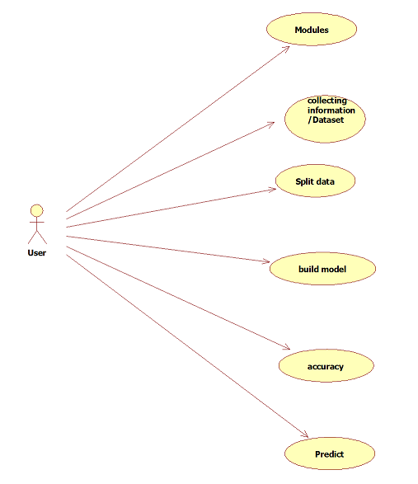

Fig 3.2: **Use Case Diagram**



Fig 3.3: **Sequence Diagram**



Fig 3.4: **Collaboration Diagram**

**4. OUTPUT SCREEN SHOTS**

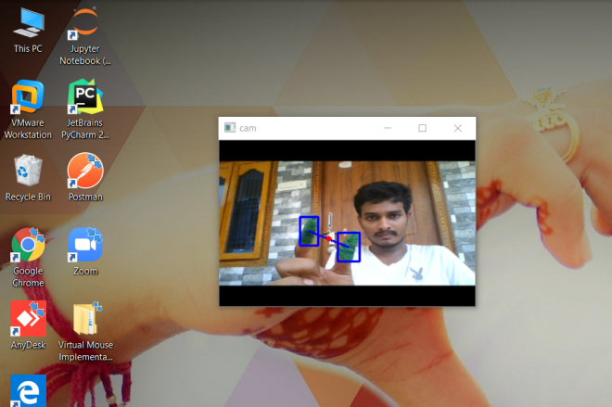

Fig 4.1

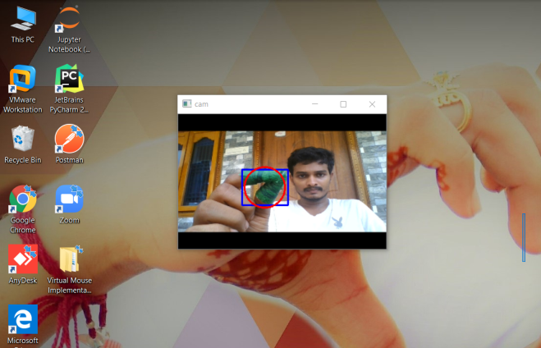

Fig 4.2

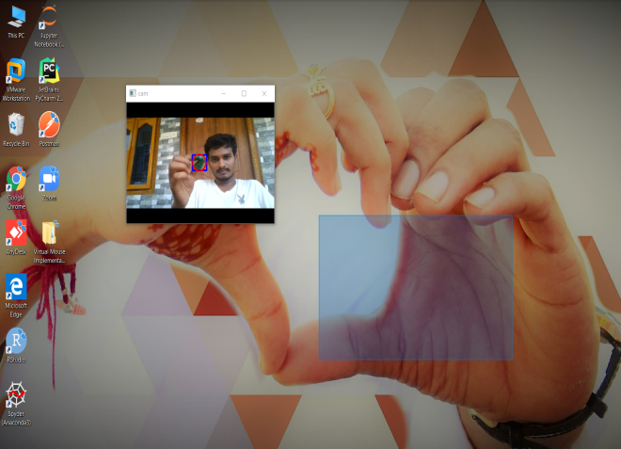

Fig 4.3

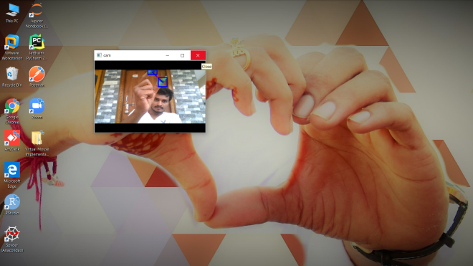

Fig 4.4

1. **CONCLUSION & FUTURE SCOPE**

This model can conclude by using the topics of computer vision like open CV, it can form masks that can variate colors by using color variation techniques and also development of mouse movement by using certain packages like ‘mouse’ which will be used for the movement of mouse by using the coordinates that are linked to the detected color. This can provide ease use of systems and many other applications. So the open CV is helping the users with different accessible forms of models that will make ease life.

**Future Scope:**

The development of these techniques and models are really vast. The color detection model can be developed if we want to identify a particular color out of a colored photo. And the mouse movement can be developed in such a way it can act like a real mouse that will help us for using system without even touching the system’s keyboard or mouse. The development can be in such a way it can be training on CNN’s that will help for a better performed model.

The Models can be developed in different ways by using some latest packages like ‘pyautoGUI’ that will help us to give commands which will identify an input and perform some function on the system. So if any separate color is detected it can perform special function or if an input from user is detected it will open any specific folder with ease without performing any actions, a simple gesture can do the job

**6. REFERENCES**

[1] Guoli Wang, (2010). Optical Mouse Sensor-Based Laser Spot Tracking for HCI Input, Proceedings of the 2015 Chinese Intelligent Systems Conference: Volume 2, pp.329-340.

[2] Anna De Liddo, Ágnes Sándor, et.al, (2012). Contested Collective Intelligence: Rationale, Technologies, and a Human-Machine Annotation. Computer Supported Cooperative Work (CSCW) Volume 21, Issue 4–5, pp 417–448.

[3] Rashmi Adatkar, Ronak Joshi, et.al, (2017). Virtual Mouse, Imperial Journal of Interdisciplinary Research (IJIR), Vol-3, Issue-4.

[4] Arul. V. H, Dr. Ramalatha Marimuthu, (2014). A Study on Speech Recognition Technology, Journal of Computing Technologies, Volume 3 Issue 7, pp 2278 – 3814.

[5] Aniwat Juhong, T. Treebupachatsakul, et.al, (2018). Smart eye-tracking system. 2018 International Workshop on Advanced Image Technology (IWAIT).

[6] Guojen Wen, Zhiwei Tong, et.al, (2009), Man machine interaction in machining center. International workshop on intelligent systems and applications. pp 1-4.

[7] S.D. Bharkad, et.al. (2017). international conference on computing methodologies and communication, pp 1151-1155.

[8] Litong Fan, Zhongli Wang, Baigen Cail, et.al (2016). A survey on multiple object tracking algorithm. 2016 IEEE International Conference on Information and Automation (ICIA)

[9] Pritpal Singh, B.B.V.L. Deepak, Tanjot Sethi and Meta Dev Prasad Murthy (2015). Real-Time Object Detection and Tracking Using Color Feature and Motion. International Conference on Communication and Signal Processing.

[10] G. Saravanan, G. Yamuna, S. Nandhini (2016). Real time implementation of RGB to HSV/HSI/HSL and its reverse color space models. 2016 International Conference on Communication and Signal Processing (ICCSP).

[11] Artificial Intelligence [Online]. Available: https://en.wikipedia.org/wiki/Artificial_intelligence

[12] Machine Learning [Online]. Available: https://en.wikipedia.org/wiki/Machine_learning [13] Open CV [Online]. Available: https://opencv.org/

[14] Convolution Neural Networks [Online]. Available: http://www.wikipedia.org/wiki/Convolution_neural_networks

[15] Pyauto GUI [Online]. Available: https://pyautogui.readthedocs.io/en/latest/

**About Authors:**

**Gubbala Durga Prasanth** is currently pursuing M.C.A in SVKP & Dr K S Raju Arts & Science College, Penugonda, West Godavari A.P. Affiliated to Adikavi Nannaya University, Rajamahendravaram. His research interests include Web Technologies , Data Analysis , Machine Learning and Artificial Intelligence.

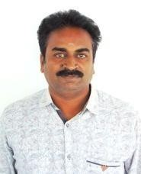**P.SRINIVASA REDDY** is working as Associate Professor in SVKP & Dr K

S Raju Arts & Science College, Penugonda , A.P. He received master’s degree in Computer Applications from Andhra University. His research interests include Operational research, Probability and Statistics , Design and Analysis of Algorithms , Big Data Analytics.